TASK 5
This data set is quite interesting as it gives us insight to a few questions; like what times of the month are buisiest (holidays, weekends, etc.), what airlines are most prone to delays, what airports are most delayed, what the average times for delays are, the time of day delays are most common, etc. While this data set only covers a few months, it can give us and others insight to the delay trends of airlines, airports, and times there are the most delays. This dataset would be very intersting to see it represented visually in different formats.

Using the 4 EDA methods, we perform the detailed analysis on our dataset.
Using barplot method, which is one of the EDA method we can answer our research questions, like which airlines has the most delay? Or on which weekday there is most number of delays?
To answer these questions we use results from our EDA.
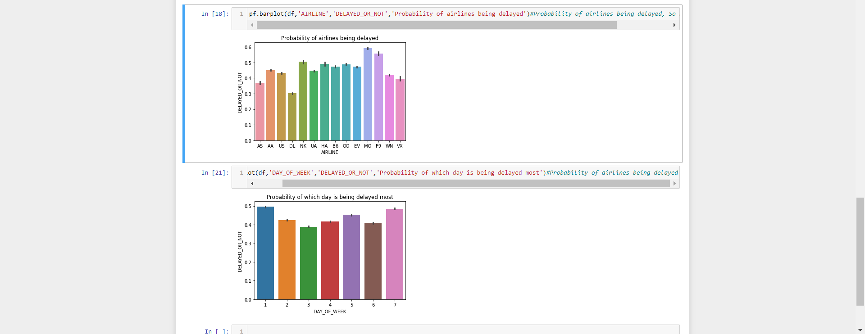
From our results we can see that for the first research question Airlines ‘MQ’ has the most delays. Moving on to our second question, we can see that on weekday 1 which is Sunday we have most delays.

